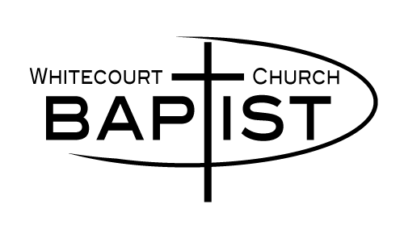
Welcome to WBC!
We are so glad you are here!
We just ask that…

- If you are not feeling well,in any way, please refrain from attending at this time (you can watch online).

- You indicate your attendance to the greeter. This will be on record for 2 weeks.

- You maintain physical distancing (2 meters) from others not within your family/cohort.

- You have your children under the age of 2yrs stay near you while within the building.

- You regularly wash your hands/use hand sanitizer (when entering or exiting the building).

- You consider wearing a mask while attending the service (they are available at the Welcome Centre).

- You refrain from singing during the service.

- Visit in the Big Room with physical distance.

Thank you for joining us and following these heath guidelines so that we honor one another and stay safe.

